Teacher’s Phlegm
Using both the illustration and its accompanying text:
- Mark the physical characteristics of the phlegmatic person by highlighting them
- Mark the emotional and moral characteristics of the phlegmatic person by underlining them.

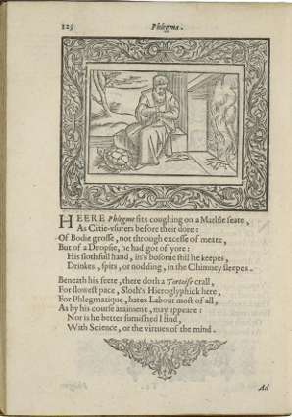
Henry Peacham, Minerva Britanna, 1612
Courtesy Folger Shakespeare Library

Here Phlegm sits coughing on a marble seat,
As city usurers before their dore [gold]:
Of body gross, not through excess of meat,
But of a dropsy [accumulation of fluid in the body],he had got of yore:
His slothful [lazy] hand in his bosom still he keeps,
Drinks, spits, or nodding, in the chimney sleeps.

Beneath his feet, there doth a tortoise crawl,
For slowest pace, sloth’s hieroglyphic here,
For Phlegmatic hates labor most of all,
As by his coarse raiment [clothing], may appear:
Nor is he better furnished I find,
With science or the virtues of the mind.

