Teacher’s Melancholy
Using both the illustration and its accompanying text:
- Mark the physical characteristics of the melancholic person by highlighting them
- Mark the emotional and moral characteristics of the melancholic person by underlining them.

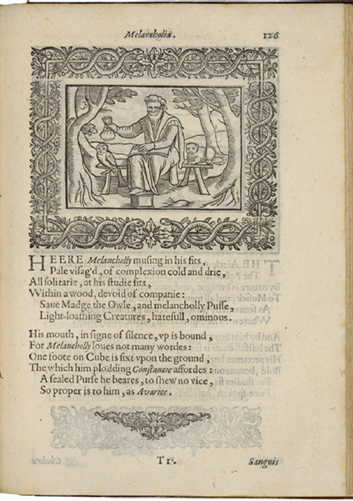
Henry Peacham, Minerva Britanna, 1612
Courtesy Folger Shakespeare Library

Here Melancholy musing in his fits,
Pale visaged, of complexion cold and dry,
All solitary, at his studies sits,
Within a wood, devoid of company:
Save Madge the owl, and melancholy Puss,
Light-loathing creatures, hateful, ominous.

His mouth, in sign of silence, up is bound,
For Melancholy loves not many words:
One foot on cube is fixed upon the ground,
The which him plodding constancy affords:
A sealed purse he bears, to show no vice,
So proper is to him, as avarice [greed].

