Teacher’s Choler
Using both the illustration and its accompanying text:
- Mark the physical characteristics of the choleric person by highlighting them
- Mark the emotional and moral characteristics of the choleric person by underlining them.

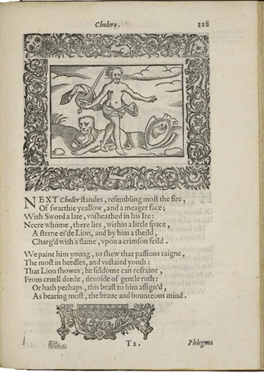
Henry Peacham, Minerva Britanna, 1612
Courtesy Folger Shakespeare Library

Next Choler stands, resembling most the fire,
Of swarthy yellow, and a meager face;
With sword a late, unsheathed in his ire [anger]:
Near whom there lies, within a little space,
A stern eyed lion, and by him a shield,
Charged with a flame, upon a crimson field.

We paint him young, to show that passions reign,
The most in heedless and unstaid youth:
The lion shows, he seldom can refrain
From cruel deed, devoid of gentle ruth [pity]:
Or hath perhaps this beast to him assigned,
As bearing most the brave and bounteous mind.

