Phlegm
Using both the illustration and its accompanying text:
- Mark the physical characteristics of the phlegmatic person by highlighting them
- Mark the emotional and moral characteristics of the phlegmatic person by underlining them.
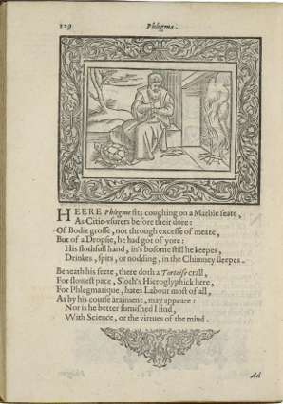
Henry Peacham, Minerva Britanna, 1612
Courtesy Folger Shakespeare Library

[Modern English Translation of the text below the illustration]

Here Phlegm sits coughing on a marble seat, just like the money lenders in the city sit in front of their gold. His body is fat, not because he eats too much meat but because he has dropsy, so fluid has collected in his body. He keeps his lazy hand in his shirt as he drinks and spits and nods off to sleep by the chimney.

A tortoise crawls beneath his feet, symbolizing his sloth, or laziness, because Phlegm hates working most of all, as his coarse clothing indicates. Nor does he like to study or put his mind to good use.

