Melancholy
Using both the illustration and its accompanying text:
- Mark the physical characteristics of the melancholy person by highlighting them
- Mark the emotional and moral characteristics of the melancholy person by underlining them.
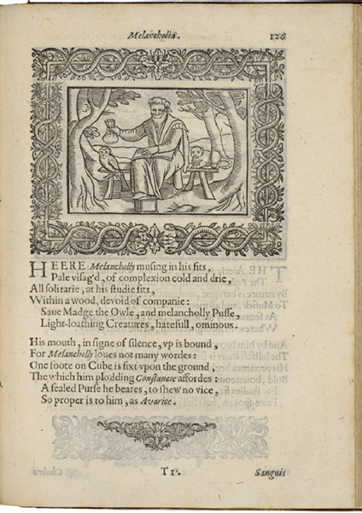
Henry Peacham, Minerva Britanna, 1612
Courtesy Folger Shakespeare Library

[Modern English Translation of the text below the illustration]

Here Melancholy, absorbed in his struggles, with a pale face and cold, dry complexion, sits by himself in his studies. He is in the woods, without any company except for Madge the owl and a melancholy cat, two hateful and ominous animals that loathe the light.

As an indication of his silence, his mouth is bound because Melancholy doesn’t like to talk. One of his feet is on a cube, fixing him firmly to the ground and providing him with a dull steadiness. He also has a sealed purse to indicate that there is no vice better suited to him than greediness.

