Choler
Using both the illustration and its accompanying text:
- Mark the physical characteristics of the choleric person by highlighting them
- Mark the emotional and moral characteristics of the choleric person by underlining them.
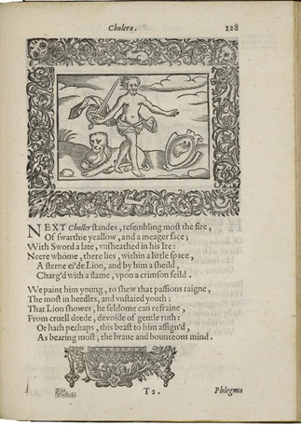
Henry Peacham, Minerva Britanna, 1612
Courtesy Folger Shakespeare Library

[Modern English Translation of the text below the illustration]

Next Choler stands, resembling fire the most, and having a face that is dark yellow and thin. He has a sword that he has taken out of its sheath in his anger, and close to him is a stern-eyed lion. He also has a shield with a flame on a crimson background.

He is painted young to show that his passions control him and that he is a thoughtless and undisciplined young man. The lion indicates that he can seldom keep from performing cruel deeds and is without pity. However, the lion also indicates that he has a brave and wide-ranging mind.

