Three Primary Sources

Instruction: Examine the images and read their titles below. Based on what you can learn and infer from them:
- Write your inferred definition of “diphtheria toxin,” “anti-diphtheritic serum,” and “diphtheria antitoxin” in the table below.
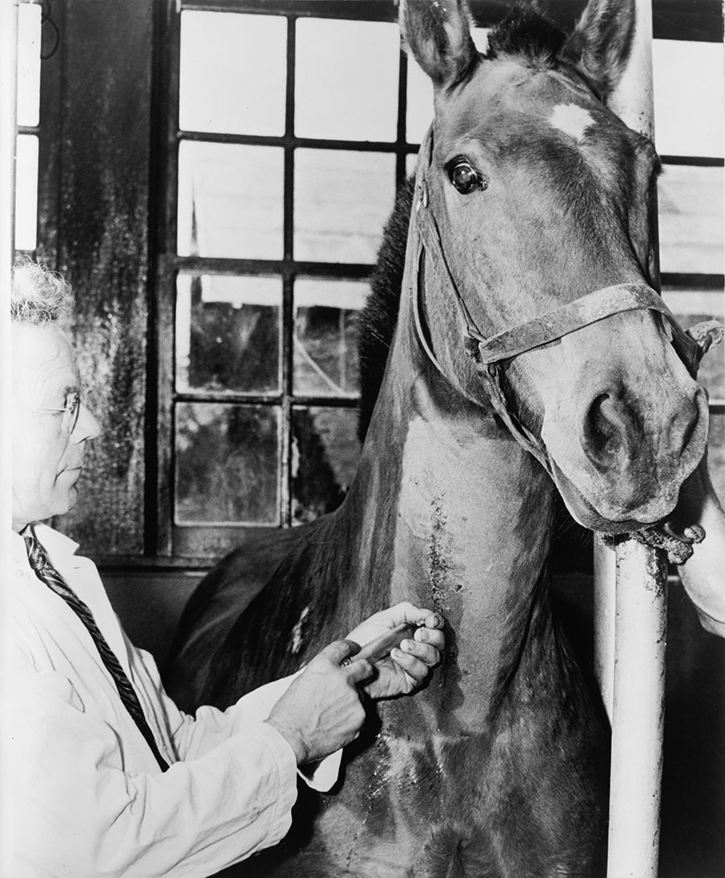  Image 1. Injecting a horse with diphtheria toxin, New York City Health Department, 1940s  Courtesy Library of Congress | 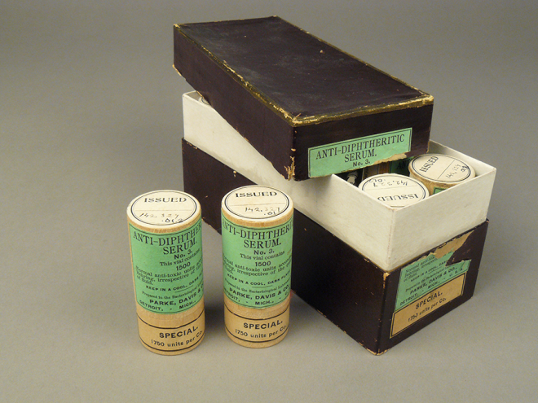  Image 2. Anti-Diphtheritic Serum, Parke, Davis & Company, ca. 1898  Courtesy National Museum of American History | 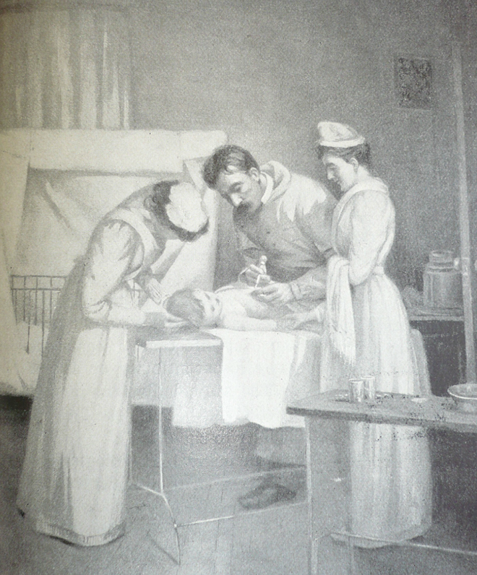  Image 3. Injecting diphtheria antitoxin, 1895  Courtesy The Historical Medical Library of The College of Physicians of Philadelphia
“diphtheria toxin”: | “anti-diphtheritic serum”: | “diphtheria antitoxin”:

- Describe or draw how the three images may be related.

